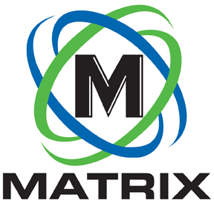
INDUSTRY ARTICLE

CONTACT:

Brian Jones
Matrix Design Group, LLC
1146 Monarch Street
Lexington, Kentucky 40513
(859) 967-1711
FOR IMMEDIATE RELEASE

Matrix Design Group Introduces the M5 Machine Mounted Methane Monitor to the U.S. Coal Market

NEWBURGH, IN. February 5, 2020 – Matrix Design Group, a leading provider of technology for mining safety and productivity, announced that the M5 Machine Mounted Methane Monitor has received MSHA approval and is now available in the US. M5 is the next-generation system from Monitech Mine Monitoring Systems of South Africa and represents a significant improvement over existing methane monitors available in the coal market. M5’s unique sensor design, system software and beacon sensor monitoring technology make it more precise and enable it to maintain a stable zero setting.

“Current methane monitors can be a hindrance to productivity either through system faults or inspection stoppages,” said David Clardy, President of Matrix Design Group. “M5 couples mine-tested technology with several new design features to help improve operational efficiency.”

The unit is highly water- and vibration-resistant, easy-to-calibrate and simple to maintain. Because users can calibrate the M5 on the display or beacon, a miner can apply test gas to the sensor and magnets to the beacon without going back to the display. And while miners still need to bump-check each shift, the 4-20 milliamps connection allows for a more stable calibration, so they generally don’t need to calibrate as often. Additionally, mines that are required to run two sensors per CM find that they only need to use one unit, since the M5 can monitor both sensors using a single controller/display and power supply. The M5 is RS485 and CAN-bus enabled, which will allow for the Methane Monitor Override Function if a system fault occurs in the face.

While M5 delivers a new monitoring technology to the US market, its maintenance is similar to currently available systems, allowing for easy adaptation for mine personnel. Matrix also has highly experienced field service staff that are available to train and advise mines as well as install and service the M5.

About Matrix Design Group, LLC

Matrix is an ISO 9001 certified designer, developer and marketer of safety and productivity technology for use in mining and industrial applications. Its innovative, industry-leading systems include proximity detection, communications, tracking, mine atmospheric monitoring, lighting and cameras. Headquartered in Newburgh, Indiana, Matrix has offices in Lexington, KY, Johannesburg, South Africa, and service locations throughout its mining regions.

-END-

