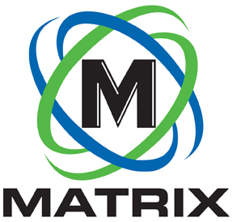
INDUSTRY ARTICLE

CONTACT:

Brian Jones
Matrix Design Group, LLC
1146 Monarch Street
Lexington, Kentucky 40513
(859) 967-1711
FOR IMMEDIATE RELEASE

Matrix Design Group Announces New Equipment Division

NEWBURGH, IN. April 29, 2020 – Matrix Design Group, a leading provider of technology for mining safety and productivity, has announced the introduction of an Equipment Division which features essential support products for underground coal operations. The new Division has launched with a product line of new or rebuilt Rock Dusters as well as Rock Dust Bins, Refuge Shelters and Dozer Kits.

“We want to offer coal mines high-quality new and rebuilt products with an eye toward cost savings,” said David Clardy, President of Matrix Design Group. “In this challenging time, mines need to maximize every dollar, and we feel that combining this new product suite with our outstanding service is a good way to support American mining.”

The line of new and rebuilt equipment will include:
- Newly designed 1,000-lb Electric Trickle Duster
- 400-lb Electric Trickle Duster
- Pull-behind Electric Beltline Duster
- Scoop Flinger Dusters
- Slurry Dusters
- Single and dual, rail or rubber-tired, Pressured Pod Duster
- Portable and stationary Rock Dust Bins
- Patented “Bottles Off”-design LifeShelters
- Dozer Rescue Kits

The Matrix Equipment Division has the ability to build new Rock Dusters or rebuild any type of Duster that the customer may have. While mines can buy ready-made products, Matrix staff will also work closely with them to customize their purchase.

“We know that the chances of a widespread explosion can be greatly reduced when rock dust is applied and maintained according to industry standards,” said Sam Kinder, Equipment Division Technical Sales Rep, “and that’s why quality Rock Dusters are so critical. We listen closely to our customer’s ideas and work to meet their exact needs to best support their employees’ safety.”

More information on the Equipment Division can be found at www.matrixteam.com/coal-mining-equipment or by calling Matrix at 812-490-1525

About Matrix Design Group, LLC

Matrix is an ISO 9001 certified designer, developer and marketer of safety and productivity technology for use in mining and industrial applications. Its innovative, industry-leading systems include proximity detection, communications, tracking, mine atmospheric monitoring, lighting and cameras. Headquartered in Newburgh, Indiana, Matrix has offices in Lexington, KY, Johannesburg, South Africa, and service locations throughout its mining regions.

-END-

