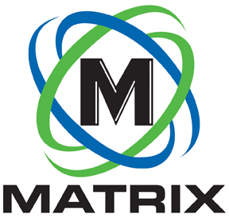
INDUSTRY ARTICLE

CONTACT:

Brian Jones
Matrix Design Group, LLC
1146 Monarch Street
Lexington, Kentucky 40513
(859) 967-1711
FOR IMMEDIATE RELEASE

Matrix Design Group Launches Matrix Analytics Group

NEWBURGH, IN. July 9, 2019 – Matrix Design Group, a leading provider of technology for mining safety and productivity, announced that it is opening a new division, Matrix Analytics Group. The division will be part of Matrix’s South African entity in Johannesburg, operating in both the U.S. and Africa. Matrix Analytics Group offers industry expert perspectives into mining operations based on data and numerical modeling that helps drive meaningful enhancements to the decision-making process.

Matrix Analytics is able to facilitate discussion aligned to the strategic goals of its clients by combining decades of mining industry expertise with modern data analytic techniques. Utilizing a model-based approach allows Matrix Analytics to provide diverse insights into business and operations.

“Current methane monitors in the U.S. coal market can be a hindrance to productivity,” said David Clardy, president of Matrix Design Group. “M5 offers dynamic technology and new design features which should improve operational efficiency.”

Matrix Analytics uses a mine’s data to find key correlations and insights and presents the information in a way that it can be used to facilitate decision making.

“A mine’s data is an often-underutilized trove of information that can dramatically improve operations,” said Stephen Redford, director of Matrix Analytics Group. “We want to provide a means for mines to tap it for key, and sometimes critical, insights.”

For more information on Matrix Analytics, contact info@matrixanalyticsgroup.com or visit www.matrixteam.com.

About Matrix Design Group, LLC

Matrix is an ISO 9001 certified designer, developer and marketer of safety and productivity technology for use in mining and industrial applications. Its innovative, industry-leading systems include proximity detection, communications, tracking, mine atmospheric monitoring, lighting and cameras. Headquartered in Newburgh, Indiana, Matrix has offices in Lexington, KY, Johannesburg, South Africa and service locations throughout its mining regions.

Matrix’s partner in South Africa is Monitech. For more information on Monitech, contact sales@monitech.co.za or visit www.monitechmining.com.

-END-

